**South Delhi Municipal Corporation Rises to the Tabighi Crisis in Full Force**

**South Delhi Municipal Corporation (SDMC)** is one of the municipal corporations in Delhi, India created after the former Municipal Corporation of Delhi was divided into three (“trifurcation”). It is also one of five local bodies in the National Capital Territory of Delhi (the others being North Delhi Municipal Corporation, East Delhi Municipal Corporation, New Delhi Municipal Council and Delhi Cantonment Board). SDMC has the unique distinction of providing civic services to a diverse spectrum of population ranging from highly upmarket residential and commercial areas to ‘urban villages’. Among these services, SDMC has done exceptional work in ensuring the provision of cleanliness and sanitation services to all its residents. Today, SDMC is showing tremendous resolve in tackling the COVID-19 pandemic that has shaken the entire country. What is more is that they have done so facing arguably the most challenging circumstances of any local body in the country – the Tablighi Jamaat that became the national headline due to it becoming one of the major CORONA hotspots of the country. However, what is even more exemplary is **the way in which SDMC managed to contain and control the spread of the virus in the neighboring communities and buildings, thereby limiting the impact of the congregation on the virus spread in the immediate vicinity, and preventing a possibly much larger crisis.**

It all began when the Islamic missionary held a religious congregation at its New Delhi headquarters in early March, where thousands of people who took part included senior preachers from Saudi Arabia, Malaysia and Indonesia where Covid-19 had already spread.  
  
After the congregation, participants left for various states, some of whom later developed symptoms of Covid-19 and quickly spread across the country thereby being termed as the ‘super spreader’. What further complicated the situation was a building near this area called the **Markaz building** where it was speculated that 2400 people, many of whom had attended the same event were locked inside as the lockdown commenced.

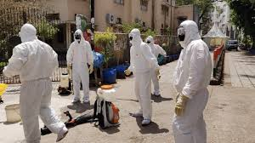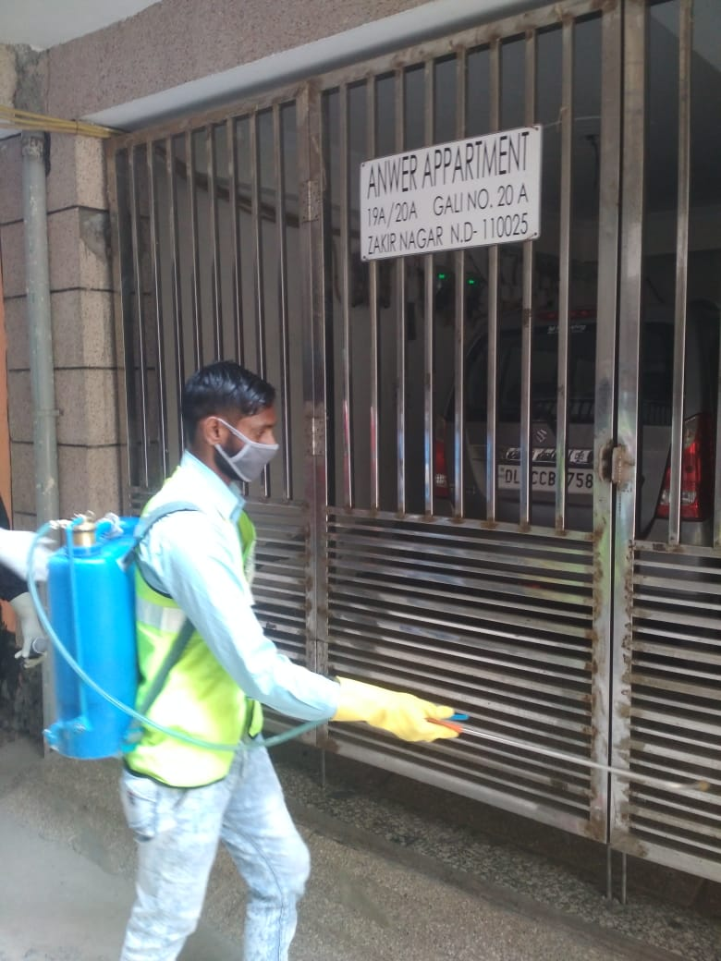SDMC however did not waste any time in responding and tackling the crisis. Cluster containment, evacuation and testing of such a large population of people was surely a daunting task. In response to this, SDMC took immediate action. **They deployed around 40 disinfectant spraying teams. A number of officials and doctors went inside the building in full body suits to gauge the situation they were dealing with.** It was concluded that buses would be used to transfer people to hospitals for further monitoring and testing. 35 DTC buses, ambulances and police vehicles used for transportation of Markaz inmates to the quarantine centres and hospitals were sanitized by Public Health workers wearing proper PPE kits**.**

**Personnel evaluating situation post Tabighi Jamaat**

**Sanitization of buildings in progress**

**In a mere three days, 2361 people were evacuated from this and tested.** With the concerted efforts of all stakeholders- SDMC, Delhi Police and frontline workers, the situation was quickly brought under control. **The outcome of this operation was that in the remainder of the Nizamuddin area (apart from the Markaz and with no relation with the Jamaat Event), only one person was found as symptomatic and has been kept under quarantine.**

**Evacuation Process from the Markaz Building**

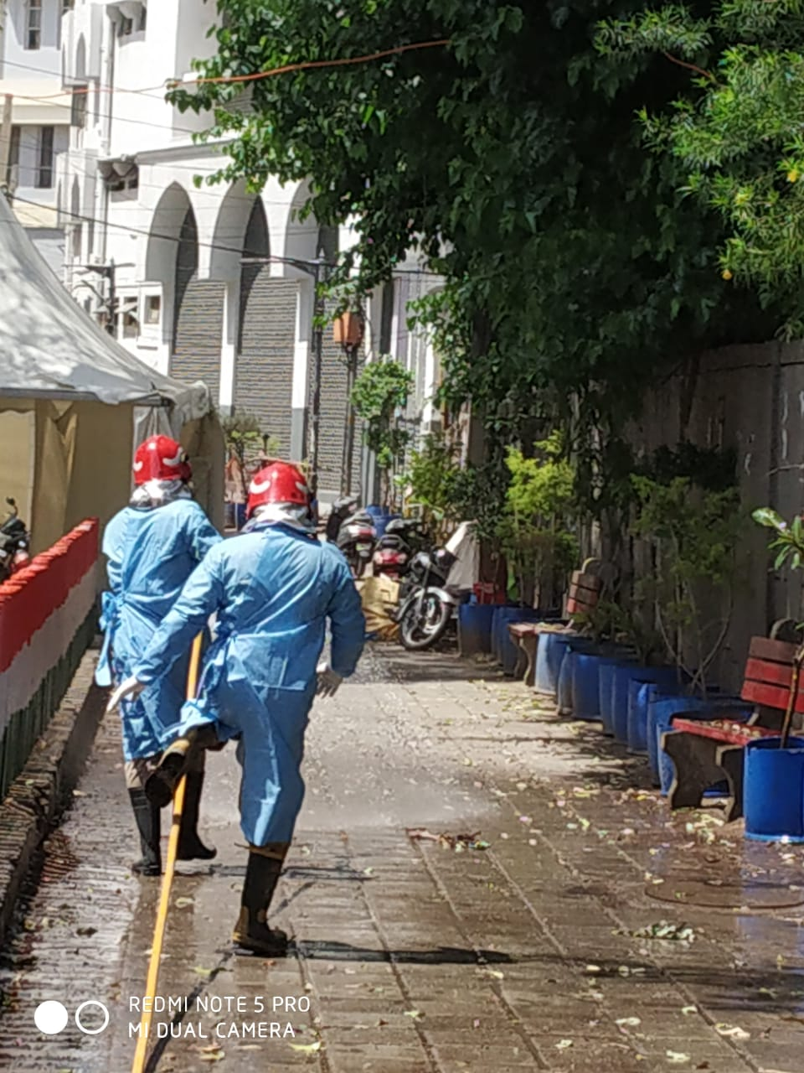SDMC has left no stone unturned and has adopted several other measures in order to contain the spread of the coronavirus within its jurisdiction. **They were agile in reacting to the sudden lockdown by initiating mass sanitization drives where the sanitized around 4200 public places**. T hese included bus stands, government offices, hospitals, clinics and several other places. Apart from this, special drives have been conducted to disinfect and sanitise areas around the quarantined households and other major hotspots.

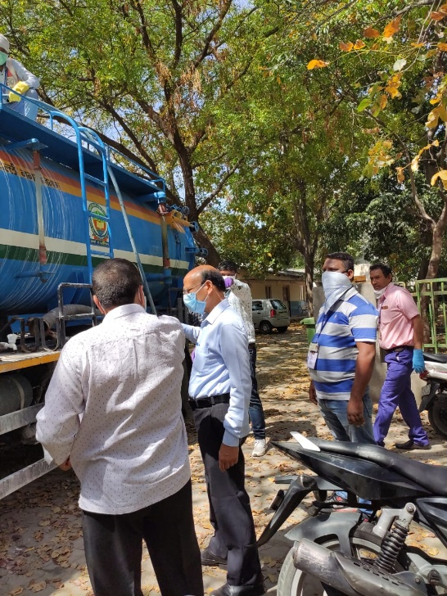

**Officials of SDMC supervising sanitization drives**

**For the sanitization of public places, 24 tankers, 24 motorized Shouldered Mounted Knapsack Teams (SMKTs), 1000 SMKTs, 32 jetting/suction machines and two drones have been employed thus far. More than 13000 Safaai Karamchaaris and 1000 auto tippers have also been involved in the disinfection process.** With such a large workforce deployed on the front lines, SDMC has ensured that there is no dearth of Personal Protective Equipment (PPE) for these warriors. Furthermore, Special Personnel Protection Equipment has been distributed amongst the staff which is responsible for the disposal of bio medical waste.

Delhi has always been an attractive location for migrant workers. But this crisis had left many of these workers rendered homeless. In order to cater to their needs, SDMC decided to **convert 91 of its Government Schools** **into shelters to accommodate hundreds of homeless and migrant workers. They also created an arrangement of food to be provided for free to the people who were being sheltered in these schools.**

**At a time when cases seemed to be on the rise,** SDMC further allowed **healthcare professionals who were ready to voluntarily provide their services free of cost at its health centres and dispensaries** in view of the spread of COVID-19. Owing to the adage, ‘There is nothing stronger than the heart of a volunteer’, **many retired doctors, new doctors and medical students voluntarily came forward to serve the nation in these crucial times.**

**Moreover,** SDMC set up **Hand washing facilities** for slum citizens, issued **Curfew Passes** to citizens to feed stray animals and also ensured that **waste** generated from **quarantine households was** picked up using special vehicles and transported to a Waste to Energy Plant for incineration.

This is an ode to the work that has been done by SDMC and other authorities preventing an already bad situation from becoming worse. With active support from citizens and volunteers, the authority has left no stone unturned to fight this crisis, particularly the one brought upon by the Tablighi Jamaat. After all, in times of distress, every little act counts.